The Journey of Pasta

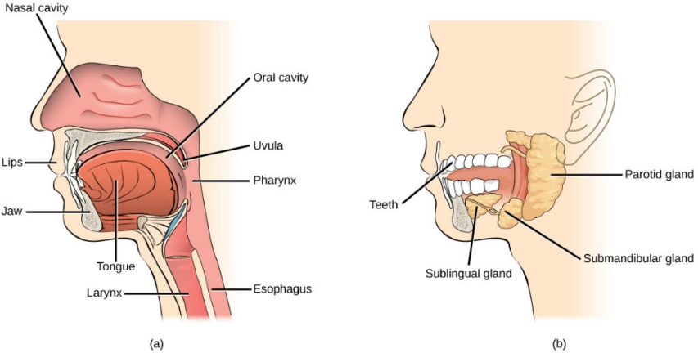**Mouth and Oesophagus**

The mouth is the start of the process of ingestion with the help of our teeth when we chew. With the lips and tongue, teeth help form words by controlling airflow out of the mouth (KidsHealth, 2018). Inside the mouth, saliva is produced by our salivary glands that moistens food and

<https://courses.lumenlearning.com/wm-biology2/chapter/parts-of-the-digestive-system/>

allows it to pass more easily through your oesophagus and into your stomach (NIDDK, 2017). At rest, the epiglottis is normally upright, allowing air to enter the larynx and lungs. When someone swallows, the epiglottis folds backwards to cover the laryngeal entrance, preventing food and liquid from entering the windpipe and lungs. The epiglottis returns to its original upright position after swallowing (MedicinePlus, 2021). The oesophagus' main job is to transport food and drink from your mouth to your stomach. The primary function of your oesophagus is to carry food and liquid from your mouth to your stomach (Cleveland Clinic, 2021).

**Stomach**

Three layers of smooth muscle line the stomach walls, organized in longitudinal, circular, and oblique (diagonal) rows. During mechanical digestion, these muscles allow the stomach to compress and churn the food. The stomach's powerful hydrochloric acid  helps in the breakdown of the bolus into a liquid called chyme (A.D.A.M., 2022). Although the stomach is the last stop for mechanical digestion, it is the first stage for protein digestion. Gastric acid in the stomach breaks down the protein chemically. Because acid prevents enzymes from working, carbohydrates stop digesting once they reach the stomach. After that, the pasta passes through the sphincter and into the duodenum (Adams, 2012).

**Small intestine (breakdown)**

Large food molecules are broken down into chemical building blocks through chemical digestion, which can then be absorbed through the intestinal wall and into the general circulation (OER services, 2022). The digestive juice produced by the pancreas contains enzymes that break down 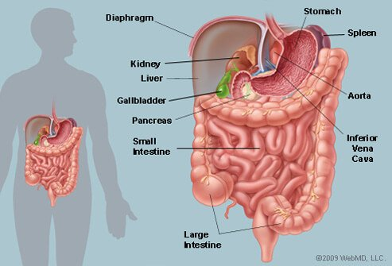carbohydrates, lipids, and proteins. The pancreas sends digestive juice to the small intestine by ducts, which are tiny tubes (NIDDK, 2017). It takes 2-8 hours for contents to be pushed gradually to the small intestine (duodenum).

**Small intestine (absorption)**

The pasta enters the small intestine, where nutrients needed are absorbed by the villi, which have a large surface area. It passes through the duodenum,

<https://www.emedicinehealth.com/image-gallery/abdomen_picture/images.htm>

jejunum, and ileum (Adams, 2012). Protein absorption also takes place in the microvilli of the small intestine. These are little, finger-like structures that improve your small intestine's absorptive surface area. This enables for maximum amino acid and nutritional absorption (Healthline, 2018). Carbohydrates are broken down into glucose molecules. It is converted into glucose molecules and transported to the liver through the bloodstream (Adams, 2012). The circulatory system, which includes the heart, blood, and blood arteries, is in charge of transporting nutrients to our body's cells. Nutrients are carried throughout the body by capillaries, which are microscopic blood channels that connect arteries and veins (Study.com, 2022).

**Material Breakdown and Use**

Pasta is high in carbs. Carbs are rapidly broken down into glucose in the bloodstream, causing a rapid spike in blood sugar (Healthline, 2017). Glucose is the main sugar in the blood. It is the body's major source of energy and comes from the food we eat. The blood transports glucose to all of our body's cells for energy production (MedicinePlus, 2017).

**Large intestine**

The large intestine's job is to absorb water and salts from food that hasn't been digested yet, as well as to eliminate any waste products. The majority of digestion and absorption has already occurred by the time food mixed with digestive juices reaches the large intestine (UPMC, 2022). The large intestine's primary function is to eliminate water and moisture from the pasta. Water from the large 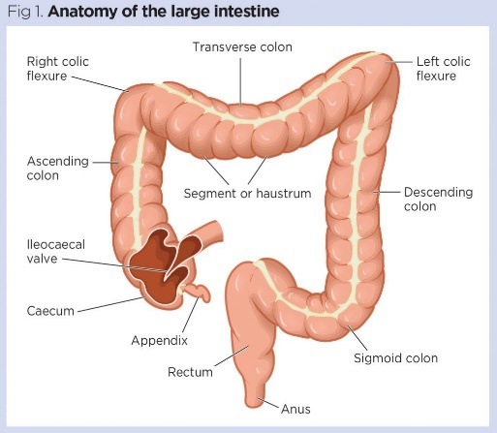intestine enters the circulation. Pasta stays in the large intestine for roughly 12 hours (Adams, 2012). The large intestine also absorbs sodium, potassium and vitamin K. However, recent investigations have revealed that the large intestine is also responsible for small amounts of calcium and magnesium absorption (Wound Management & Prevention, 2022). Many of the large intestine's bacteria can further digest some materials, resulting in gas production (MSD MANUAL, 2022). The bacteria helps break down big food molecules into useable fuel (Jakob, 2022). The large intestine produces slow movement which takes 18-24 hours the pass.

<https://www.nursingtimes.net/clinical-archive/gastroenterology/gastrointestinal-tract-5-anatomy-functions-large-intestine-23-09-2019/>

**Elimination and Faeces**

Elimination is the process of removing undigested wastes from the anus in the form of faeces (NIH, 2022). Faeces are made up of what’s left over after our digestive system (stomach, small intestine, and colon) absorbs nutrients and fluids from the foods and beverages you consume (MedicinePlus, 2015). After the digestive process is complete, the intestines use the muscular walls of the small bowel to push faeces into the rectum. The rectum is where faeces are stored until defecation. When the rectum is full, stretch receptors in the wall sense it and stimulate the need to pass faeces through the anus (Millar, 2022).

**References**

Encyclopedia, M. (2022). *Epiglottis: MedlinePlus Medical Encyclopedia Image*. Medlineplus.gov. Retrieved 7 May 2022, from <https://medlineplus.gov/ency/imagepages/19595.htm#:~:text=The%20epiglottis%20is%20usually%20upright,to%20its%20original%20upright%20position>.

Works, Y. (2022). *Your Digestive System & How it Works | NIDDK*. National Institute of Diabetes and Digestive and Kidney Diseases. Retrieved 7 May 2022, from <https://www.niddk.nih.gov/health-information/digestive-diseases/digestive-system-how-it-works#:~:text=bile%2C%20and%20enzym122es-,Mouth.,down%20starches%20in%20your%20food>.

*Esophagus: Anatomy, Function & Conditions*. Cleveland Clinic. (2022). Retrieved 7 May 2022, from <https://my.clevelandclinic.org/health/body/21728-esophagus#:~:text=The%20primary%20function%20of%20your,to%20your%20throat%20(pharynx)>.

*Mouth and Teeth (for Parents) - Nemours KidsHealth*. Kidshealth.org. (2022). Retrieved 7 May 2022, from <https://kidshealth.org/en/parents/mouth-teeth.html#:~:text=With%20the%20lips%20and%20tongue,food%20in%20preparation%20for%20swallowing>.

*Digestive System Information*. Pennstatehershey.adam.com. (2022). Retrieved 7 May 2022, from <http://pennstatehershey.adam.com/pages/guide/reftext/html/dige_sys_fin.html>.

*The Digestion Process of Pasta*. prezi.com. (2022). Retrieved 7 May 2022, from <https://prezi.com/jrkah7ctry7h/the-digestion-process-of-pasta/#:~:text=The%20stomach%20is%20the%20last,acid%20prevents%20enzymes%20from%20working>.

*Chemical Digestion and Absorption: A Closer Look | Anatomy and Physiology II*. Courses.lumenlearning.com. (2022). Retrieved 7 May 2022, from <https://courses.lumenlearning.com/suny-ap2/chapter/chemical-digestion-and-absorption-a-closer-look/>.

*The Digestion Process of Pasta*. prezi.com. (2022). Retrieved 7 May 2022, from <https://prezi.com/jrkah7ctry7h/the-digestion-process-of-pasta/#:~:text=The%20pasta%20enters%20the%20small,down%20carbohydrates%20into%20glucose%20molecules.&text=into%20glucose%20molecules%20it%20is%20carried%20through%20the%20bloodstream%20to%20the%20liver>.

*Chemical Digestion: Definition, Purpose, Starting Point, and More*. Healthline. (2022). Retrieved 7 May 2022, from <https://www.healthline.com/health/chemical-digestion>.

*How are Nutrients Transported Around the Body?*. Study.com. (2022). Retrieved 7 May 2022, from <https://study.com/academy/lesson/how-are-nutrients-transported-around-the-body.html>.

*Your Digestive System & How it Works | NIDDK*. National Institute of Diabetes and Digestive and Kidney Diseases. (2022). Retrieved 7 May 2022, from <https://www.niddk.nih.gov/health-information/digestive-diseases/digestive-system-how-it-works>.

Link, R. (2022). *Is Pasta Healthy or Unhealthy?*. healthline. Retrieved 7 May 2022, from <https://www.healthline.com/nutrition/is-pasta-healthy>.

Topics, H. (2022). *Blood Sugar | Blood Glucose | Diabetes | MedlinePlus*. Medlineplus.gov. Retrieved 7 May 2022, from <https://medlineplus.gov/bloodsugar.html#:~:text=Blood%20sugar%2C%20or%20glucose%2C%20is,cells%20to%20use%20for%20energy>.

*Differences in Small & Large Intestines | Children's Pittsburgh*. Children&#39;s Hospital of Pittsburgh. (2022). Retrieved 7 May 2022, from <https://www.chp.edu/our-services/transplant/intestine/education/about-small-large-intestines>.

*The Digestion Process of Pasta*. prezi.com. (2022). Retrieved 7 May 2022, from <https://prezi.com/jrkah7ctry7h/the-digestion-process-of-pasta/#:~:text=The%20main%20job%20of%20the,hours%20in%20the%20large%20intestine>.